**Raising Awareness of Cervical Cancer**

Cervical cancer is the most common cancer in women under 35, which is why in the UK regular screening is offered to all women between the ages of 25 and 64 years under the NHS Cervical Screening Programme. Finding abnormalities early means they can be monitored or treated, greatly reducing the chance of cervical cancer developing. It is stated that screening could prevent 99.8% of cervical cancer cases in the UK. Despite this, attendance rates for cervical cancer screening are on a decline. Exploring why this is happening and providing information surrounding the topic in an attempt to improve screening attendance is vital.

**Project Aim:** To raise awareness about issues surrounding cervical cancer enabling people to make more informed decisions.

**Project Objectives:** To raise cervical cancer awareness, explore the cause for the decline in screening attendance and reasons for this. To emphasise the benefits of cervical screening and how important it is for women to attend. Visually show distribution of the disease worldwide over different age ranges and indicate areas with screening and the HPV vaccination available. Finally, highlight factors that may increase risk of contracting cervical cancer.

**Intended Audience:** The project’s target audience is primarily women however, the information displayed could be useful to anyone for raising awareness. This information visualization would be best displayed in places such as health centers and hospitals and is designed for use on a device such as an interactive touch screen iPad.

**Design Decisions:** Initially all information was to be displayed on one page in a modular layout, however due to the amount of information to be displayed, a tabular design was deemed a better option. This layout was also considered to be best for interaction on a device such as a tablet or phone. Arial was chosen as it is a sans serif font and clear to read. The main colours selected were a dark pink and blue, these are the colours used by Cancer Research UK and therefore may be more relatable for the target audience.

**Tab One - Why?:** The aim of this tab was to give the audience an opportunity to interact and feel involved and to also see that other women might feel the same about cervical screening as them. A few designs were generated (Figure 1, 2 and 3). Ten people were then asked which design they thought was the most effective. Design three was chosen as people thought the strengths of the design included it being interactive giving the target audience the opportunity to think about why they wouldn’t attend and see how many felt the same. People also thought that the inclusion of a quote could help people to see why the reason should not prevent them from attending screening.

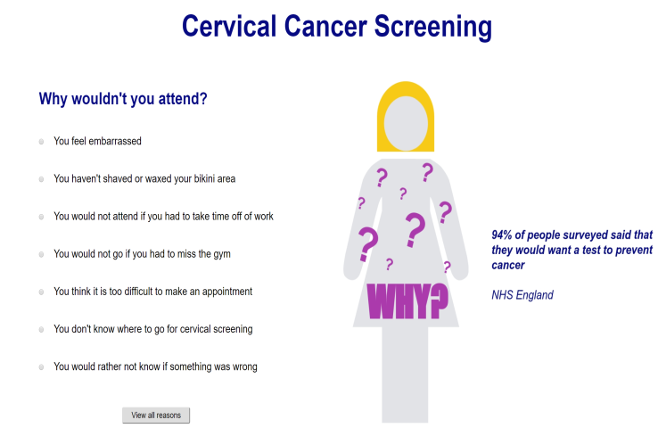**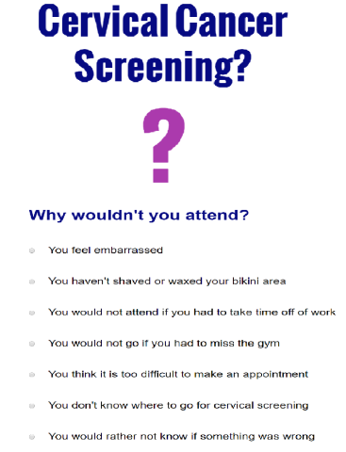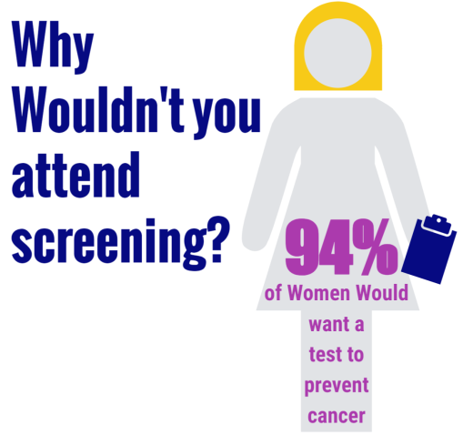 Figure 1 Figure 2 Figure 3**

**Tab Two - Screening:** Highlighting the fact that 99.8% of cases are preventable seemed to be a very important point and therefore this was positioned on the left-hand side of the screen. It was decided that a significant aspect of the project was also the decrease in screening attendance in the UK. A graph to display a comparison of the age groups decreasing attendance was placed on the right side of the screen to visualise this fact.

**Tab Three - World Map:** This tab was designed to show the distribution of cervical cancer across the world and also to highlight the difference between cervical cancer distribution and that of all cancers. It displayed that incidence of cervical cancer was high in Africa as opposed to other countries however the trend for all cancers was shown to be the opposite. People viewing the information graphic are able to see both dynamically or by selection how age has an impact on incidence and mortality rates across the world. Furthermore, it was important to display if screening is available and if the HPV vaccination is available worldwide (yes = green, red = no) as this was going to be able to suggest if this correlated with the incidence and mortality of the disease. Another aspect that was added to the map was the option to click on a country and view how the mortality had changed since 1950, this was included so that it was possible to look at different countries to visualise either a reduction in cervical cancer mortality or an increase.

**Tab Four - Risk Factors:** This was designed to indicate to the audience what risk factors increase the chance of contracting cervical cancer. Information graphics that were designed needed to be simple but eye catching and informative. Graphics chosen for this page included risk factors such as HIV/AIDs, smoking, number of children per women, number of sexual partners, long term use of contraceptive pill and having children at a younger age. Statistics of how these risk factors affect different regions of the world was also considered. I decided that bar graphs upon click of the graphics would be a good way to display this information allowing the target audience to explore the information visualisation further if they wish to know more information surrounding the topic. Colours chosen for the bar charts were consistent with regions always being displayed in the same colour**.**